☆Let us expand our circle of friends by learning the cultures of various nations ! ☆
We will also have stage performers to introduce to us their culture's music, songs and dance! You are very welcome to come and join us at the stage!
Yataimura 2016
～Let's drink, eat, sing and dance！～
31th of July, 2016 (Sun.) from 3:00 until 8:00 pm at BellFarm

《What is Yataimura?》
It's an event in which various countries promote their culture and its' products, like drinks, food and a lot more!
We will also have stage performers to introduce to us their culture's music, songs and dance! You are very welcome to come and join us at the stage!

《Participating parties and their country's 「Greetings」》
Let's have an exchange of greetings to the new people/friends whom we will meet at Yataimura!
☆China 你好 ☆Thailand สวัสดีครับ ☆Philippines Magandang hapon
☆Korea 안녕하세요 ☆Myanmar Mingalaba ☆India Namaste
☆Japan Konnichiwa ☆Spain Buenas Tardes ☆Peru Buenas Tardes
☆Morocco Ssalamu`lekum ☆Vietnam Xin Chao
☆America Hello ☆Brazil Boa tarde
※ In some cases, there may be changes to some of the participating country.
《What is Matsusaka City Multicultural Promotion Council?》
The purpose of Matsusaka Multiculture is to support foreigners living in this city to be able to live a good life without being discriminated.
On April of 2015, both public and private organizations decided to create more programs that would help and support foreigners seek solutions to their problems by giving advise o giving appropriate consultations. We would also like to promote more activities in which people of different nations interact with eachother.

《How to get to Bell Farm》
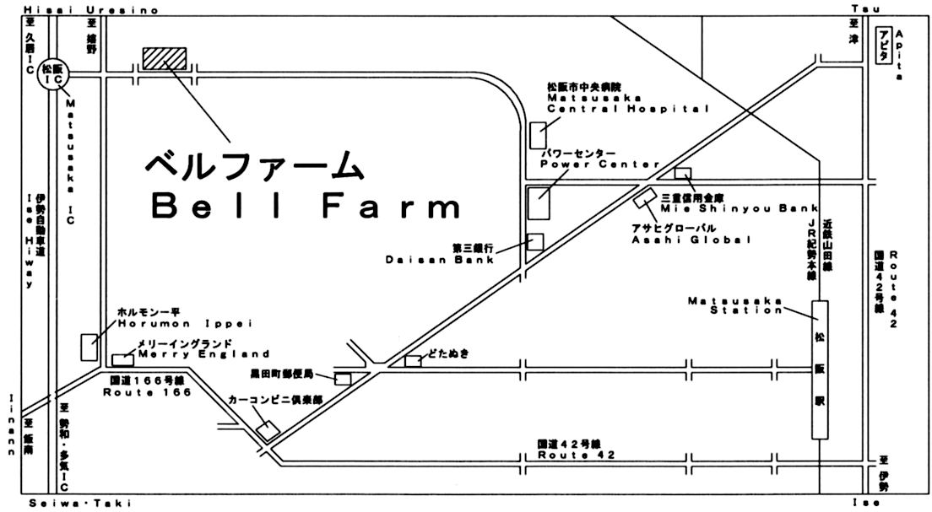
松阪市黒田町郵便局
Matsusaka City Kuroda Machi Post Office

